Luke Roberts

Chesterfield College Dynamic Web and Media Assignment 2

FdSc Applied Computing

Figure 1 (logo)



Supporting Documentation for MSM Driving School’s Updated Website

Contents

Introduction/ Background 2

Requirements 2

Additional Requirements 2

Design: Logo 2

Icon 3

Colour Scheme 4

Font-Logos and Banners 4

Layout 5

Screenshots 7

Future Developments. 12

Code Snippets 12

HTML 12

CSS 14

JavaScript 16

# Introduction/ Background

My driving instructor and I were having a conversation recently about how his website has some discrepancies that need resolving. How he also wanted a fresh new look to his website as well as some out of date information that needs taking out. I said I could just start from the beginning and make him a completely new website with new features and a logo.

# Requirements

* Homepage – with a logo produced by you using image manipulation software and an external stylesheet which follows through all pages of the website.
* Multiple pages so there is content for users to navigate through.
* It must contain several original media assets; images, video, flash etc.
* There must be some interactive content.
* There should also be an enquiry/contact form.]

# Additional Requirements

* Some of the information on his current website Is now untrue. Some text elements need removing or editing.
* The previous designer also added a watermark that that externally links to his website, I’ll make sure not to do this.
* He wants his website to have responsive design. This is to make sure the website is fully functional across all devices.

# Design: Logo

Initially I had a concept of putting the letters in the shape of a car and decided to stick to that. Although I did have variations and iterations of my first design.

|  |  |
| --- | --- |
|  | **C:\Users\luke\AppData\Local\Microsoft\Windows\INetCacheContent.Word\logog concept 2.jpg** |
| **Logo Design 1(Figure 2)** | **Logo Design 2 (Figure 3)** |
|  |  |
| **C:\Users\luke\AppData\Local\Microsoft\Windows\INetCacheContent.Word\concept 3.jpg** | **C:\Users\luke\AppData\Local\Microsoft\Windows\INetCacheContent.Word\concept 4.jpg** |
| **Logo Design 3 (Figure 1)** | **Logo Design 4 (Figure 4)** |

**Logo Design 1**

This was my first attempt at the logo design that was in my head. I wanted to make the initials of the company in the shape of a car. However, the resolution was too low and the colours didn’t look good so I started again from scratch but kept the same idea.

**Logo Design 2**

The second installation of my idea was an immense improvement. The first design was made in about 5 minutes, much more time was spent on this iteration. I made sure that it was a suitable resolution and that the image didn’t look pixelated. The black background is only to show the white outline around the image. I felt that the letters were covering up too much of the cars features so I decided to mess around with the transparency and create a third design.

**Logo Design 3**

The third design is my favourite, it shows the features clearly enough. This is the final logo design. The format is a png which means it has a completely transparent background. However, I can always add a background in future if necessary as I have a png and a psd document saved.

**Logo Design 4**

The fourth design is a result of having some constructive feedback after showing the third design. It was suggested that the car in the background should be removed as it makes the logo look a little complicated. After experimenting in photoshop and trying to change the logo too be a better iteration than the third. I decided it was impossible. After a certain time trying, I came up with this design. In retrospect, I prefer design 3.

# Icon

I only had one design in mind for this project. I am sure it is a standard design for most driving school websites. It’s an L plate.

**(Figure 5) Learner icon**. This design is so simple, I created it using an online tool that makes your canvas 32x 32 the standard favicon size. I didn’t want it to be transparent as I thought it would look more like the real thing with a plain white background, it also goes well with the dark aesthetic of the website.

# Colour Scheme

The client wanted to stick with his original colour scheme, shown below.

|  |  |  |  |
| --- | --- | --- | --- |
|  |  |  |  |

I think these colours go well together as it makes for a modern look.

The black make the website feel premium and modern, websites today like Netflix have opted to have black as the main colour as opposed to a white, grey, beige, type colour scheme looks dated in my opinion.

The red and white symbolise the driving school colours, the learner plate is red and white, it also stands out from the black making the text very easy to read.

They grey is there for another dark colour, a colour that you can see is different from the black, I didn’t want too many bright colours as I didn’t want to bedazzle the user. Having 2 dark and 2 bright colours is easier on the eyes, and looks more professional, in my opinion.

# Font-Logos and Banners

Haettenschweiler is the font I chose for the logos and banners as I wanted a tall, bold font to really standout against the other plain text in the html.

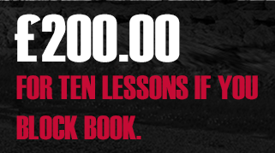**(Figure 6) example of logo and banner font.**

**Font-HTML**

The font family I chose was Ariel, sans serif. I don’t like the lines at the ends of letters, this font is easy to read and a standard font in html. I think it looks professional.

**(Figure 7) Example of html font.**

# Layout

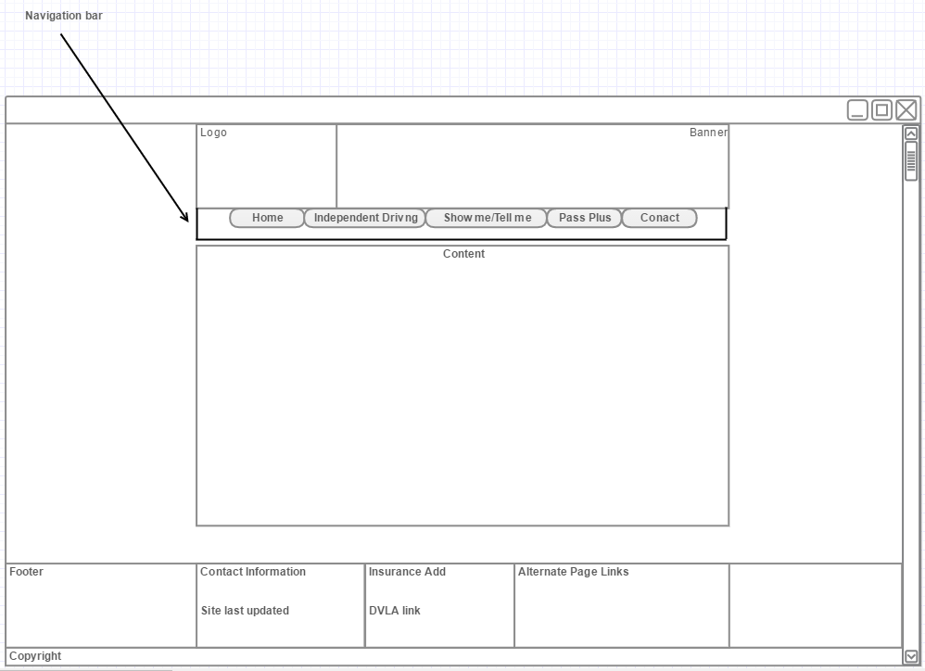

**(Figure 8) First layout design.**

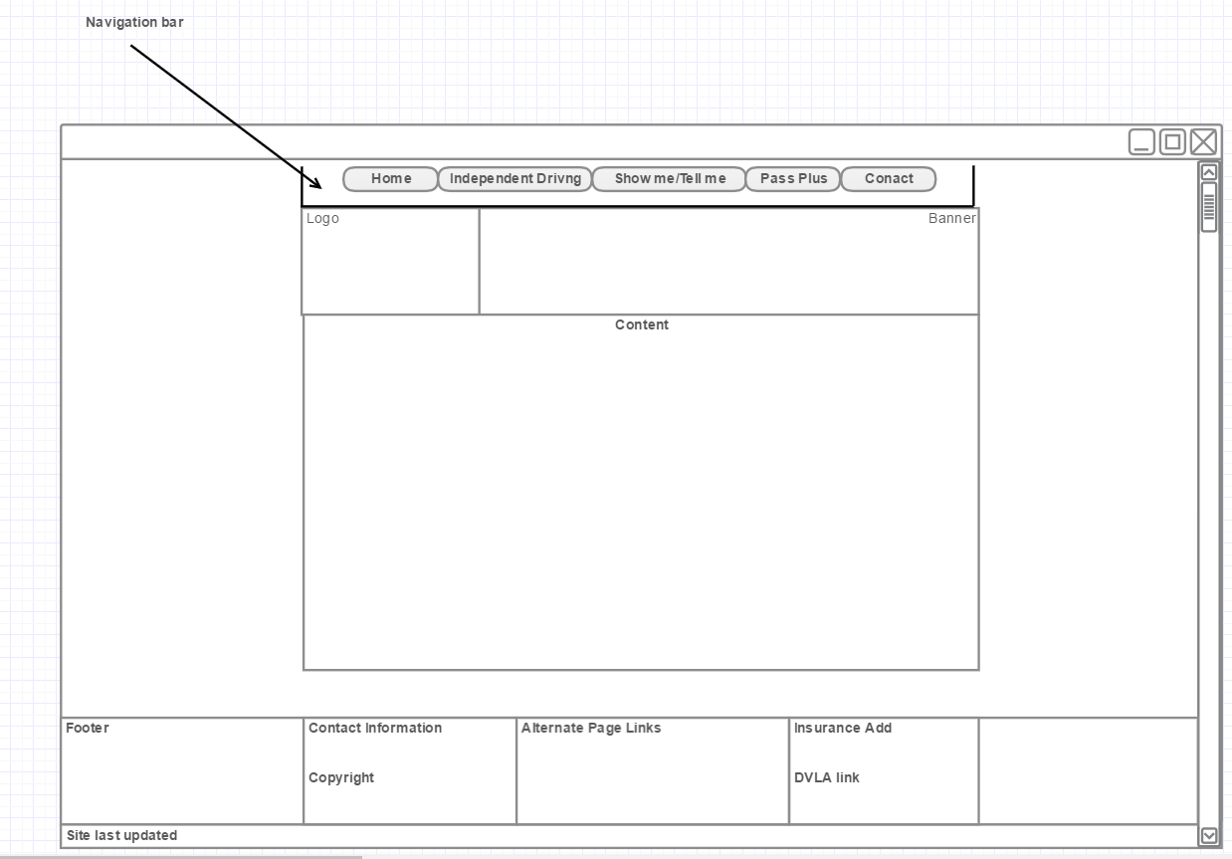

**(Figure 8) alt web page design.**

The first design is the one I ended up going with as I felt it looked cleaner with the navbar bellow the banner. A decent website should always have the main content of the website in the middle of the page and starting from near the top. This is to reduce difficulty of the users finding the key information they are looking for. A footer should have additional content. The footer resides always at the bottom and is located on every page. It has an advert for cheap learner’s insurance and alternate links to other pages of the website and external pages, as well as some basic contact information.

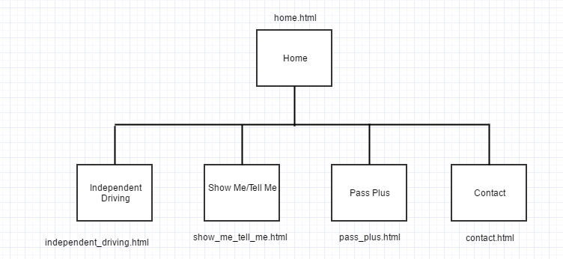

**(Figure9) Site Map** This is the site map it shows the structure of the web site and where everything is located.

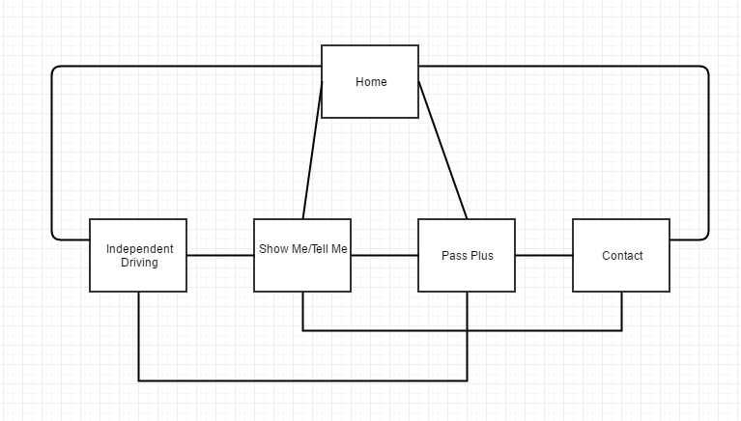

**(figure10) Navigational Structure.** This shows how each and every page can be accessed through each and every other page on the website.

# Screenshots

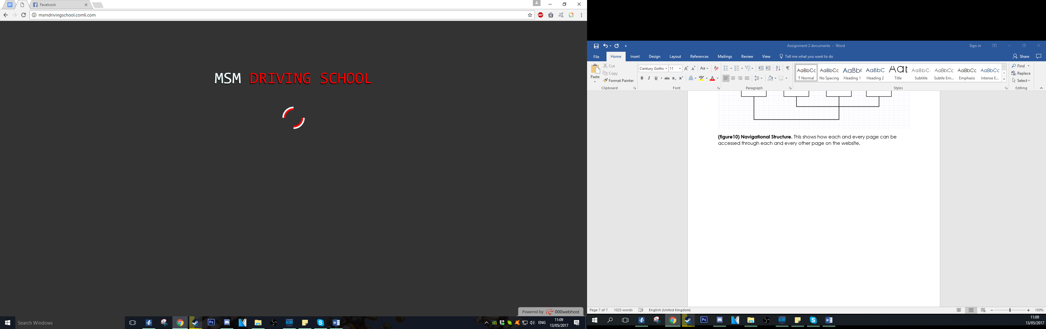

**(figure 11) Splashscreen.**

This screenshot shows a preload splash screen. It was created using a mix of java script, HTML, and CSS. Its purpose is to load this as the pictures and other media are loading in the background.

Banner Navigation bar Promo Banner

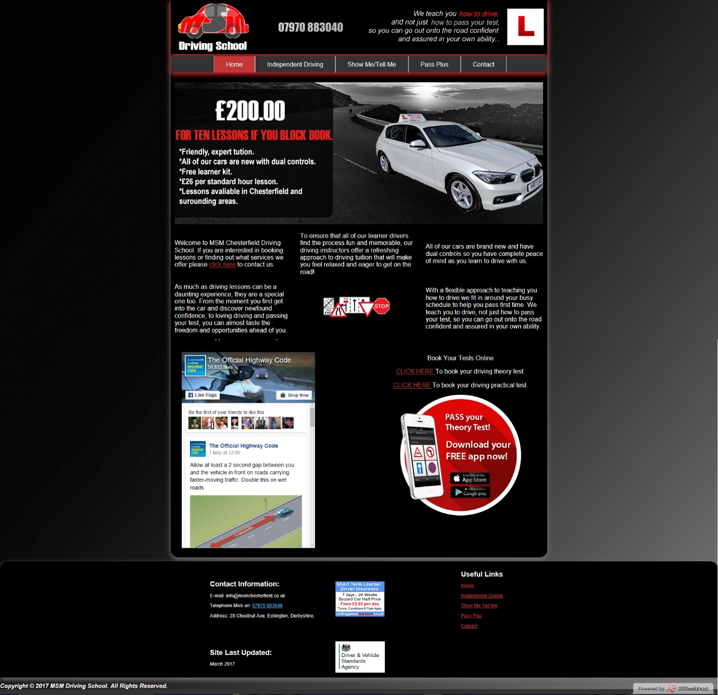

Hyperlink

Main content

Imbedded Facebook page.

Advertisements

Contact information  
Copyright notice site last updated Advertisement

**(Figure 12) Features annotated.**

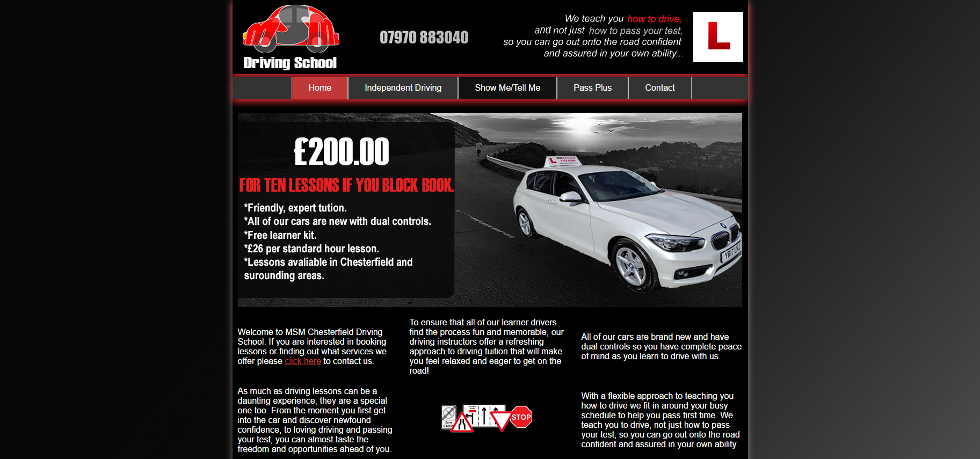**(Figure 12) Top of home page.**

This is the top of my home page of my website. This screen loads up after the flash screen animation is complete. The navigation bar is near the top, this is how the pages will be primarily navigated.

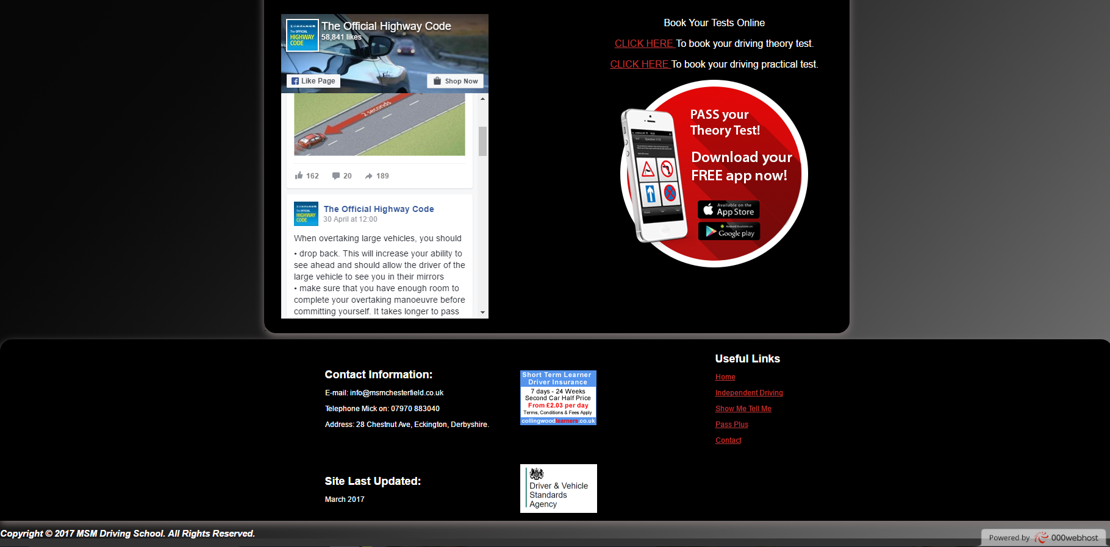

**(Figure 13) Bottom of homepage.**

This is the bottom of my home page. It shows an imbedded Facebook page on the website. It was created with the tool that Facebook provides call “Facebook for developers” and is an Iframe element. This is one of the reasons why my website is not validated. “The scrolling attribute on the iframe element is obsolete” This is a problem that is beyond me skill set/time frame to fix. It also has 3 pictures that link to external websites. And some alternate links to other pages in the footer. A site last updated and copy right notice is also shown, the site last updated is there to show the user when it was last updated, this can be a good thing as the information is most likely to still be true.

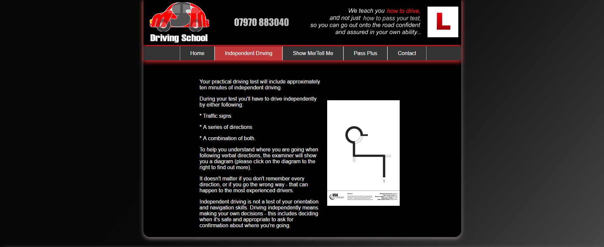

**(figure 14) Independent Driving Page.**

This page is a lot simpler than the last page. It is simply some text next to an image. the image links to more information about the independent diving section of a practical driving test.

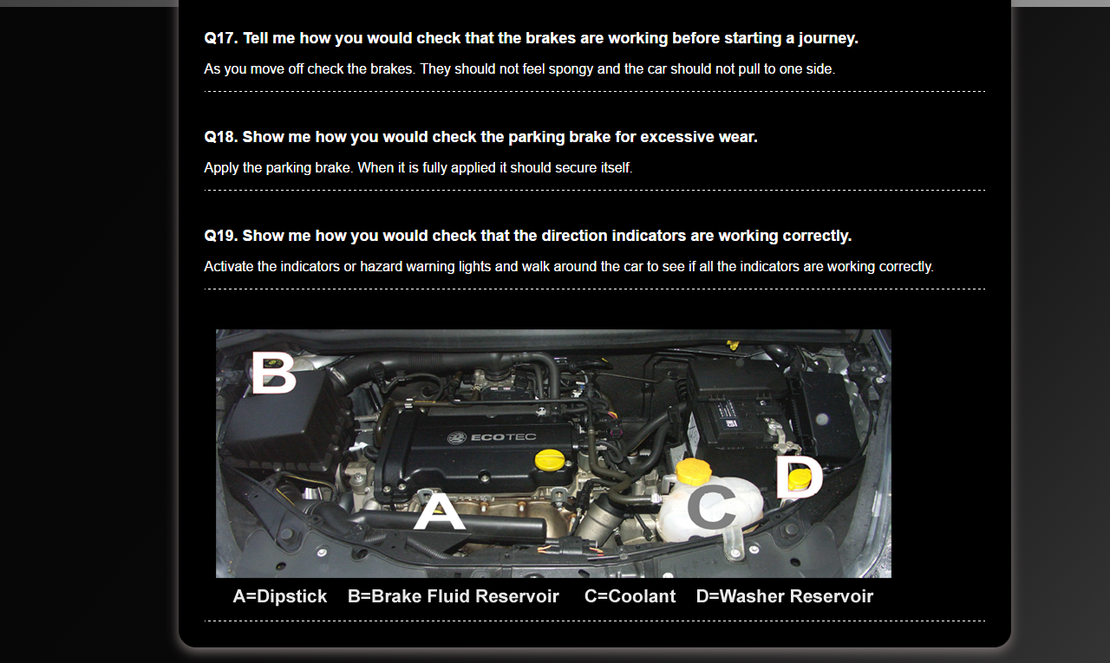

**(Figure15) Show me Tell me page**

This is the bottom of the show me/ tell me page. I didn’t show the top as it is just a list of the questions 1-16 and the usual nav bar and banner. This was created with simple html, using headings and paragraphs that were stylised in the CSS document. Each question and answer set is broke apart with a hr tag that is also styled in CSS.

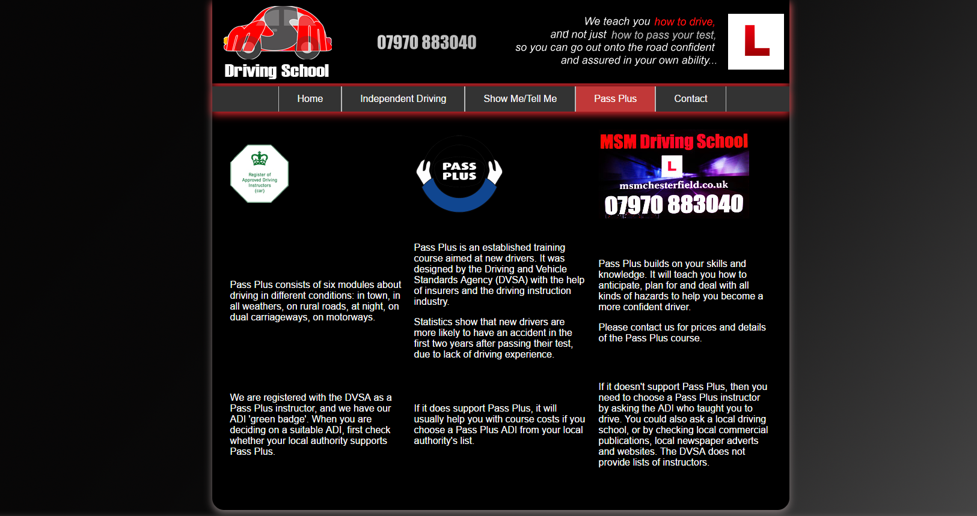

**(figure 16) Pass plus page**

This is another simple page. It consists of various images and 3 columns.

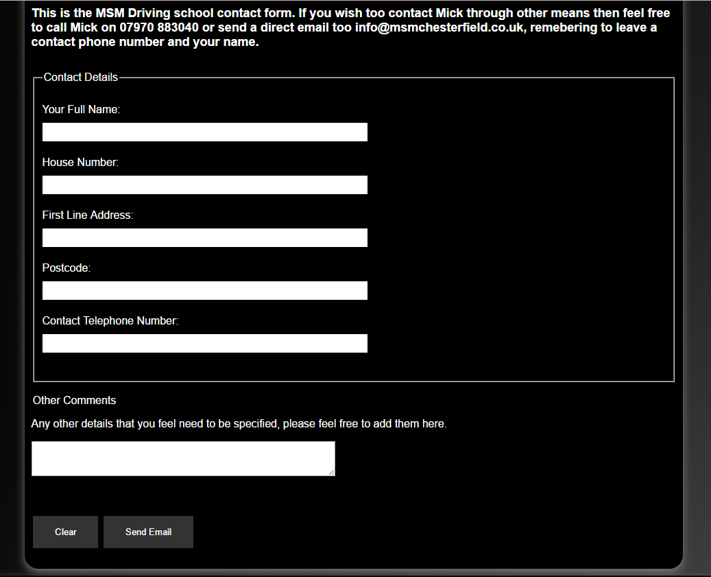

**(figure 17) Contact page.**

This is the contact page. It shows my contact form. The buttons all work and the text boxes work as well. The only thing I couldn’t do was to send the actual form data to an email address without the need of it trying open an external app. This could be a feature that I could experiment with in future but, I didn’t have enough time to be able to do that.

# Future Developments.

I have listed some things I would like to fix or add to the website above but I will list summarise them here.

I would like the website to have responsive resolution, this is so the website would be easier to use on smaller screened smart phones and devices with an overall smaller screen resolution. To achieve this I would need to make multiple CSS documents and play around with the width and height of some of the divs. This process would take some time hence why I have not tried to implement it in this project.

I would like the contact form to send the messages directly to the email without it trying to open an email app in windows. This would make the site more streamlined and user friendly. They would just get sent to the email address and from the driving instructors inbox, it would say something like “message from Website contact form.” I would need to learn how to use Ajax for this too work properly and again this would be too time consuming.

A search tool is also a handy thing to add, if a user is looking for some key information and can’t find it. Then maybe a search function would be convenient.

Validation makes a website look more professional. If the tools Facebook give you or out of date then I say that they should be the ones to fix that so many other websites can be validated.

# Code Snippets

# HTML

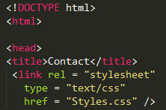**(figure18) Declaration**

Here you can see I have declared the document type as a html. This is to ensure full compatibility with all web browsers even out of date versions of old web browsers. You can see that the syntax is correct and the stylesheet is correctly linked.



**(figure19) href and paragraph usage.** This highlights how I have used href to link to an external website and the use of a paragraph.

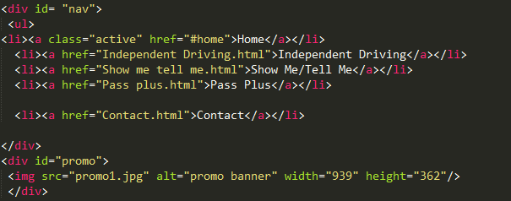

**(figure 20) Div usage, adding an image and navigation bar.** My navigation bar is a simple list with links in it. The way it looks on the website is mostly linked to the CSS. Here you can see I have also used a div, divs separate different content so they can be edited more easily using CSS and be given certain rules. You can also see how I have added the promo image.

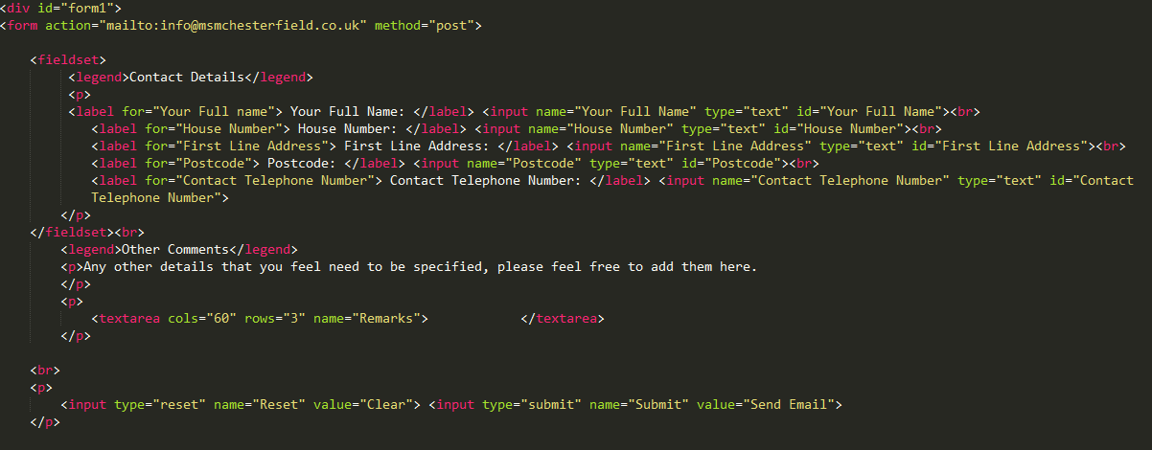

**(figure 21) Form code.** This is how my form was designed in html, the font style and textbox widths were created in the css.



**(figure 22) Facebook.** Here is the code directly taken from the Facebook for developers tool.



**(figure 23) Headings.** Here is an example of using headings in my html.

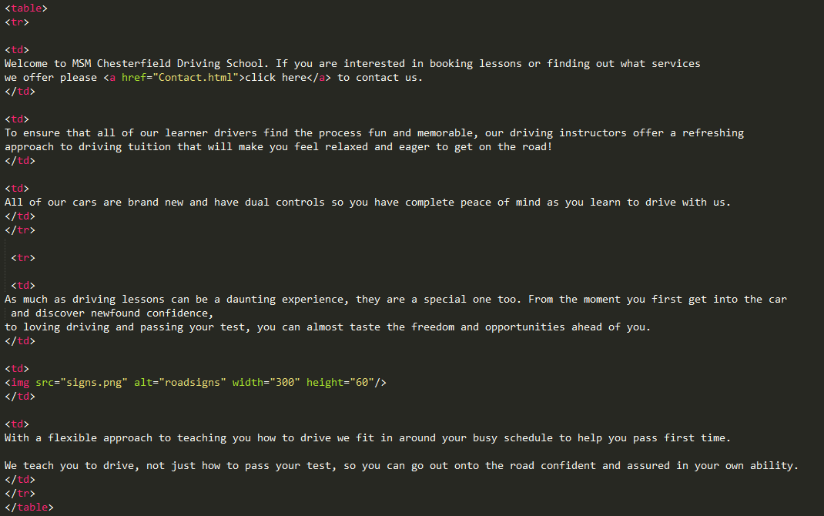

**(Figure 24) Tables.** Using tables is an effortless way to show data.

# CSS

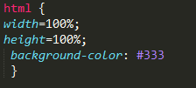

**(figure 25) html styling.** Here we can add assorted colours to the background for all pages and change the border properties.

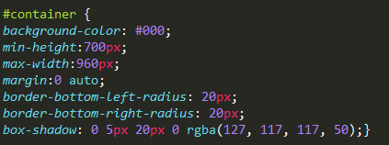

**(figure 26) Styling a div.** This is the container where the clear majority of information is stored is styled. The max width and height control the size of the div. The margin code positions the content inside that div. the border bottom text gives us the rounded corners of my container and the box shadow gives the fade of colour around the outside.

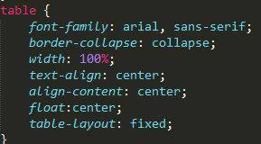

**(figure 27) table styling.** This is the styling for all tables on my website. The border collapse gives the tables no borders. Text align, align content and float control positioning of content and text.

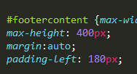

**(figure 28) Padding.** Padding is the code we use to give gaps between content.

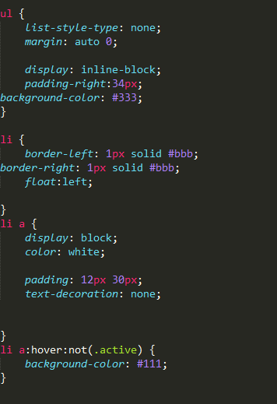

**(figure 29) Navbar and list styling.**

Border adds an outline to the buttons. list type gives the list a default list in this case. The hover not tool shows a different colour when hovering over a button. Active background-colour: #c13838; allows a colour to be shown when that page link is active.

# JavaScript

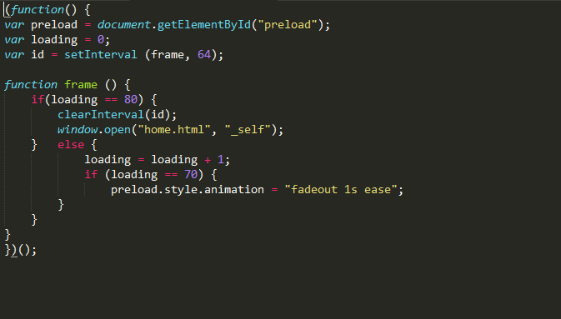

This JavaScript was needed for my animated. It deals with the loading of the page and when the splash screen should disappear. It shows that it will be there for 64 frames. And when loading is complete it shall do another animation “fadeout” for 1 second before making the home.html page visible.